**Project 5 Part 3 Canny Edge Detection Complete**

Name: Arnav Jain Period: 3 Date: 1/30/22

Is your lab name l053?(lowercase L followed by digits 053) yes

**Did you test your code on a school terminal using c++11?** yes

Does your main method call only part3()? yes

Did you create a gray image? yes

Did you apply the Sobell operator? yes

Did you apply a double threshold? yes

Did you apply non-max suppression? yes

Did you test using command line arguments? yes

Paste here **5 clear pictures** of the initial picture (image.ppm0, the grey image (imageg.ppm), the image obtained after applying hysteresis & double threshold (image1.ppm), the image you obtained after applying non-maximum suppression (image2.ppm), the image obtained after applying both (imagef.ppm):

Image:

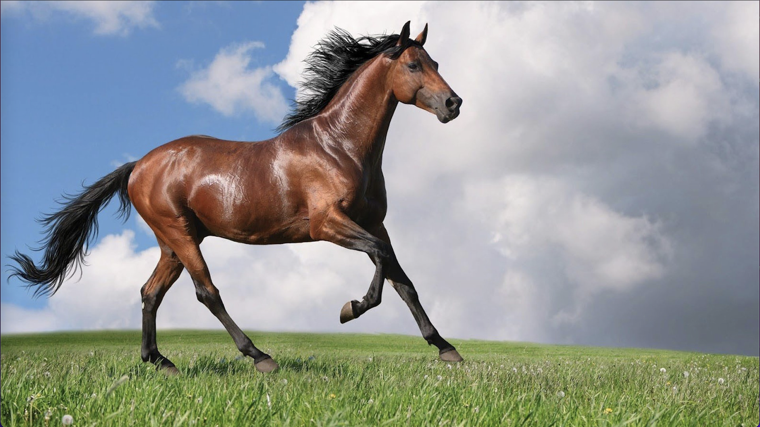

Imageg:

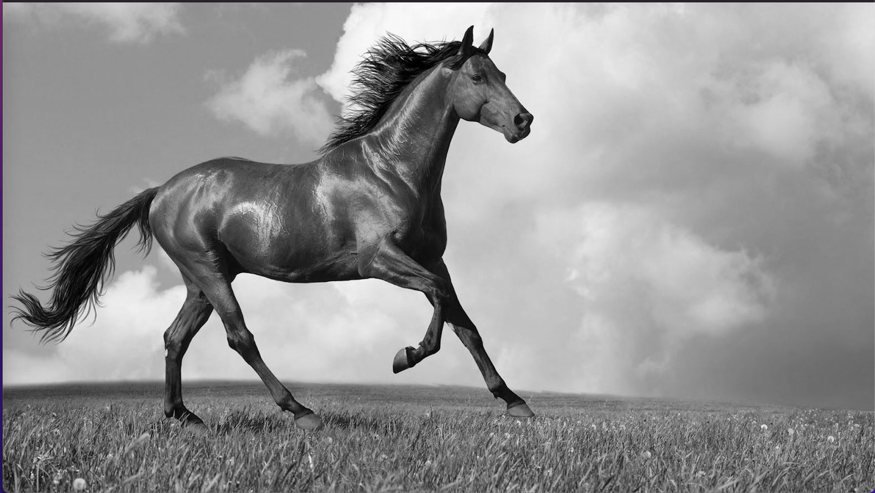

Image1:

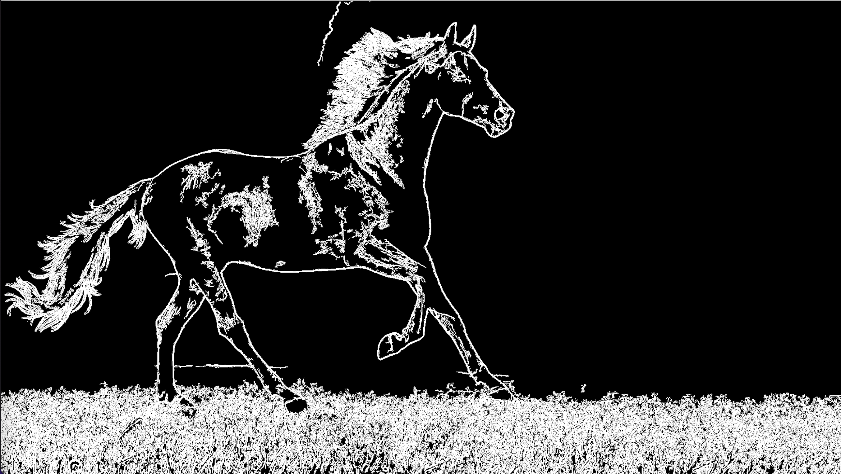

Image2:

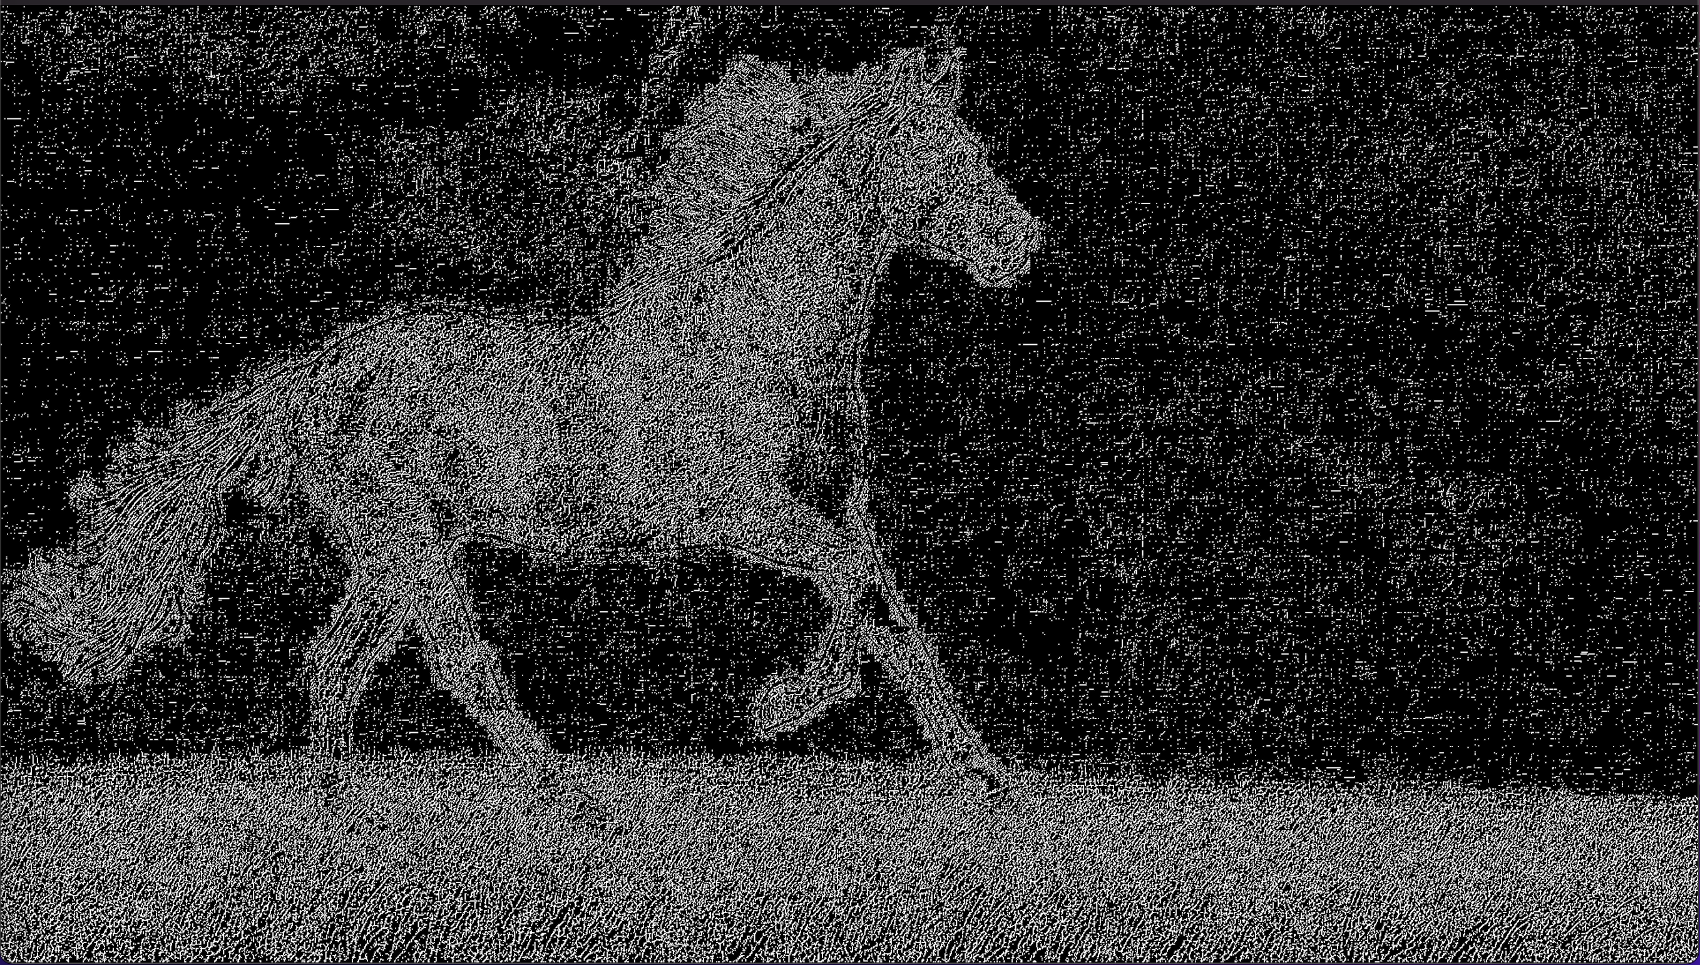

Imagef:

